www. learnpolish.org

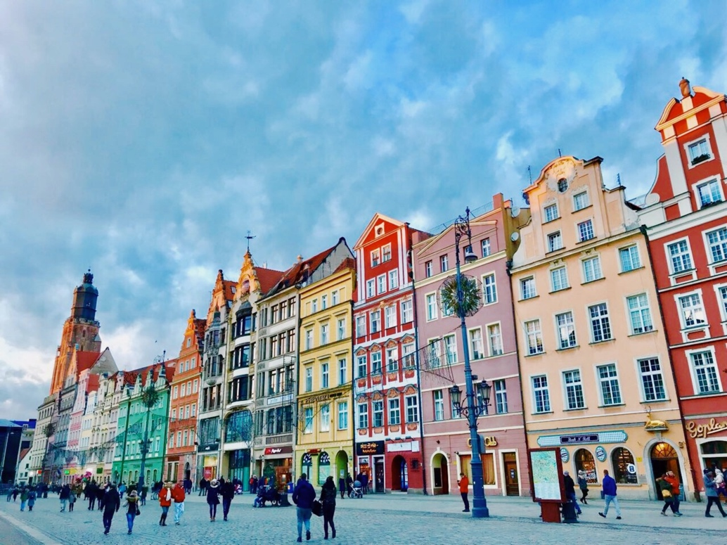
Wroclaw

2024 SPRING SEMESTER OF
ONLINE POLISH LANGUAGE AND CULTURE CLASSES

Name . . . . . . . . . . . . . . . . . . . . . . . . . . . . . . . . . . . . . . . . .
Contact Phone Number . . . . . . . . . . . . . . . . . . . . . . . . . . .
E-Mail Address: . . . . . . . . . . . . . . . . . . . . . . . . . . . . . . . . .

I am registering for:
Beginners I - Thursdays (Feb. 8 - May 9)
Beginners II. - Wednesdays (Feb. 7 - May 8)
Intermediate - Tuesdays (Feb. 6 - May 7)
Advanced - Mondays (Feb. 5 - May 6)
All classes meet on Zoom
6:30 - 8:20 pm
Fee: $450
Tuition is fully refundable only within the first two weeks of classes
Please send your registration and a check to:
Barbara Bernhardt
18705 Falling River Dr.
Gaithersburg, MD 20879

OR:
You can also VENMO the tuition to
Barbara Bernhardt@BasiaBernhardt

Please tell me the reasons you are learning Polish. What are your motivations and goals? What are your previous experiences with the language?

………………………………………………………………………………………………………………………………………………………………………………………………………………………………………………………………………………………………………………………………………………………………………………………………………………………………………………………………………………………………………………………………………………………………………………………………………………………………………………………………………………………………………………………………………………………………………………………………………………………………

If you have any questions, please email me at: bernhardtbasia@gmail.com
or call: 240 338 2592
Thank you!

